Christopher Peng

**Exercise 3: Deliverable 1**

1. **Overall Activity Decline:**
   * Player activity has significantly decreased from 2021 to 2023. In 2021, over 190,000 matches were started, but by 2023, only 236 matches occurred.
   * Retention rates dropped, except for a small group of loyal players who stayed active, showing a **10% retention rate** in 2023. *(see fig. 4)*
     + However, with that 10% retention rate only included 10 Distinct Users still playing the game
   * Drop off Rates further display the decline of the game with Distinct Users decreasing by 98.70% in the first year to the second year and an additional 78.26% drop off rate in the second year to third year *(see fig. 1-3)*
   * The low number of distinct users and high number of matches started further indicate the loyalty of the small fanbase for the game, however even with the most loyal of players, only 10 distinct users ended up continuing to play in 2023 *(see fig. 4)*
2. **Engagement and Retention:**
   * Across most regions, retention is generally low, with an overall average retention rate of **3.07%**. This indicates that only a small percentage of players return to engage with the game after their initial matches. *(see fig. 5.)*
   * The average win rate stands at **3.23%**, revealing that most players are unable to secure wins, which may contribute to the overall decline in player activity and retention. *(see fig. 6)*
   * Notable countries with the highest win rates and retention rates include:
     + **Bermuda:** Win Rate - **15%**, Retention Rate - **12%**
     + **Bahrain:** Win Rate - **10%**, Retention Rate - **9%**
     + **Belarus:** Win Rate - **8%**, Retention Rate - **7%**
   * These countries demonstrate significantly better engagement metrics compared to the overall averages, suggesting that localized strategies could be effective in improving performance in other regions.
3. **Drop-Off Funnel Rates:**
   * The player journey reveals a significant drop-off from match start to win *(see fig. 1-3)*:
     + **3,585 distinct players** started a match.
     + **3,430 distinct players** completed a match, indicating a drop-off of **155 players** (approximately 4.3%).
     + **1,186 distinct players** won a match, showing a substantial decline from completion to winning, with **2,244 players** (approximately 65.5%) not achieving a win.
   * This funnel highlights that while most players are willing to complete matches, the transition to winning is a critical area for improvement. Enhancing gameplay balance and player skills could help reduce this drop-off.
4. **Percentage of Distinct Players vs. Total Matches *(see fig. 7):***
   * The distinct player metrics compared to total matches indicate a concerning trend:
     + **Total Matches Started:** 192,890
       - **Percentage of Distinct Players:** **1.86%** (3,585 distinct players)
     + **Total Matches Completed:** 177,265
       - **Percentage of Distinct Players:** **1.94%** (3,430 distinct players)
     + **Total Wins:** 5,960
       - **Percentage of Distinct Players:** **19.88%** (1,186 distinct players)
   * These percentages suggest that a relatively small proportion of the total player base is engaging with the game, highlighting the need for strategies to increase player participation and retention.
5. **Regional Trends:**
   * Key markets like the US, China, and Germany show high match activity but average win rates (around 2-4%). Smaller regions, like Bermuda, have higher win rates but low retention.
   * 2023 saw a steep decline in matches, indicating possible game design issues or market changes. However, the players who remain engaged seem highly loyal.

In summary, although overall activity is down, focusing on match completion, reducing drop-off rates, and enhancing engagement strategies based on geographic performance could help retain players and potentially reverse the decline in player engagement.

**Supporting Charts / Graphs**

**Fig. 1 (Funnel Rates for 2021)**

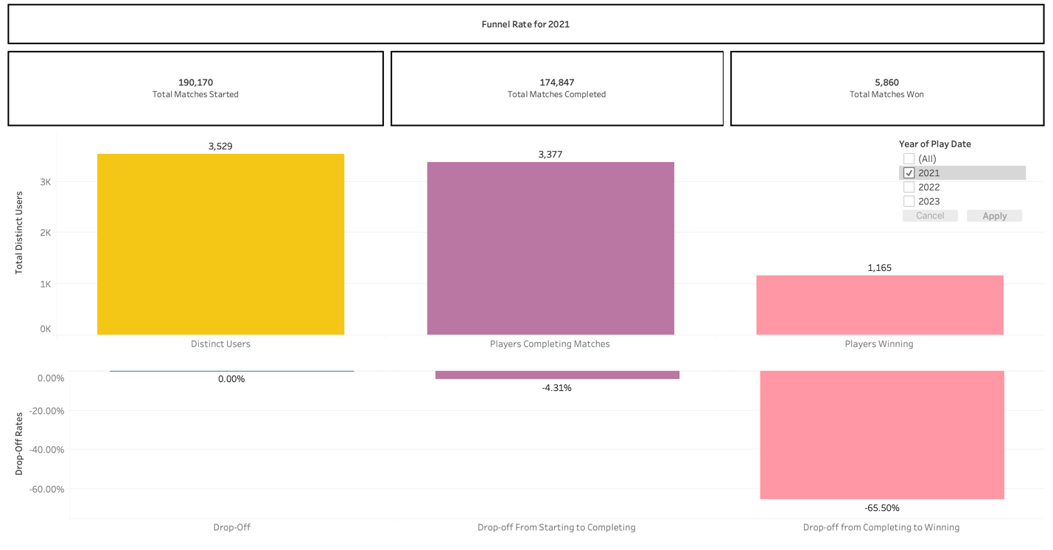

**Fig 2 (Funnel Rates for 2022)**

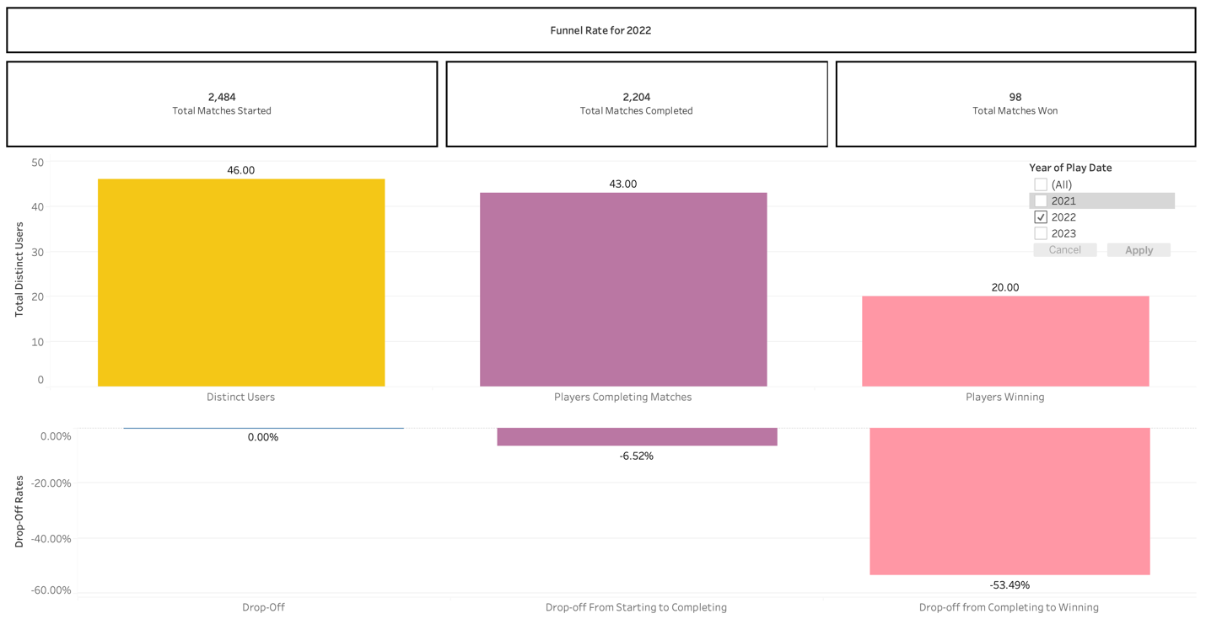

**Fig. 3 (Funnel Rates for 2023)**

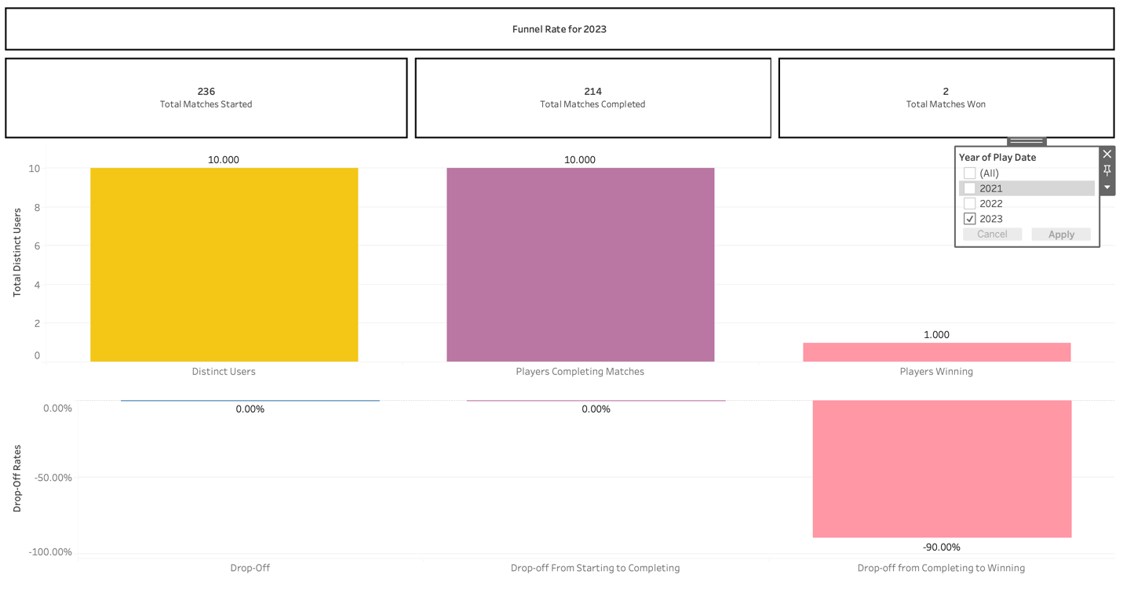

**Fig 4 (Total users vs Total Distinct Users)**

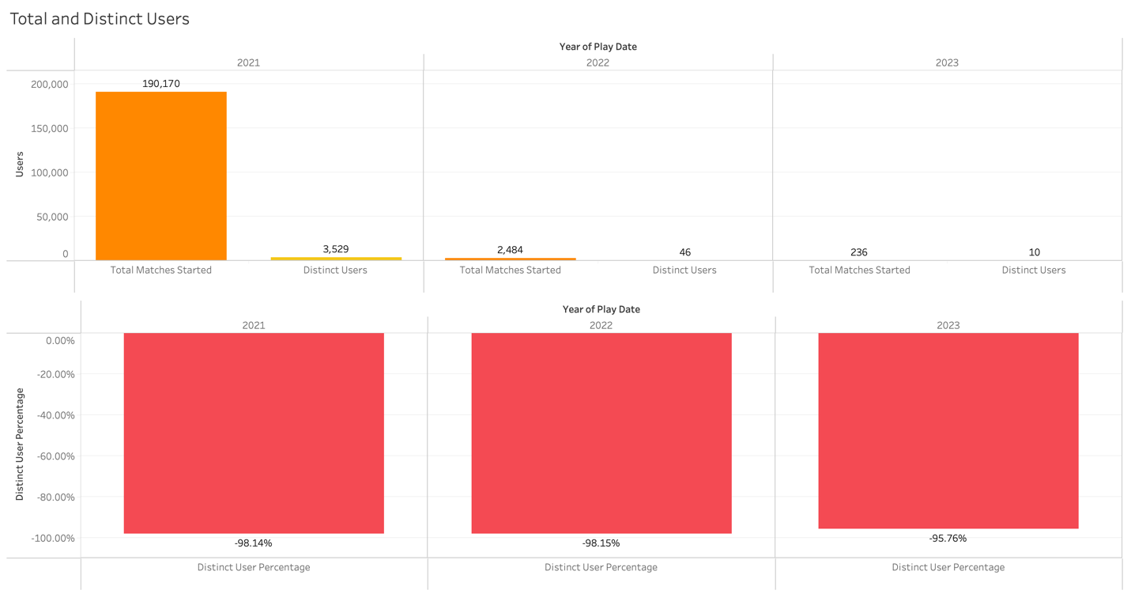

**Fig 5 (Retention Rate by Country)**

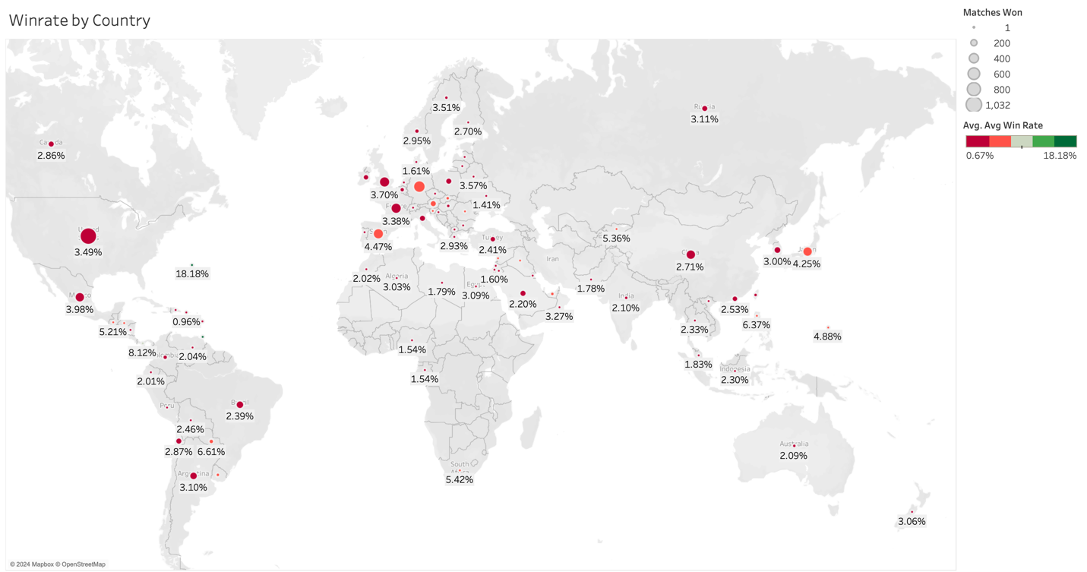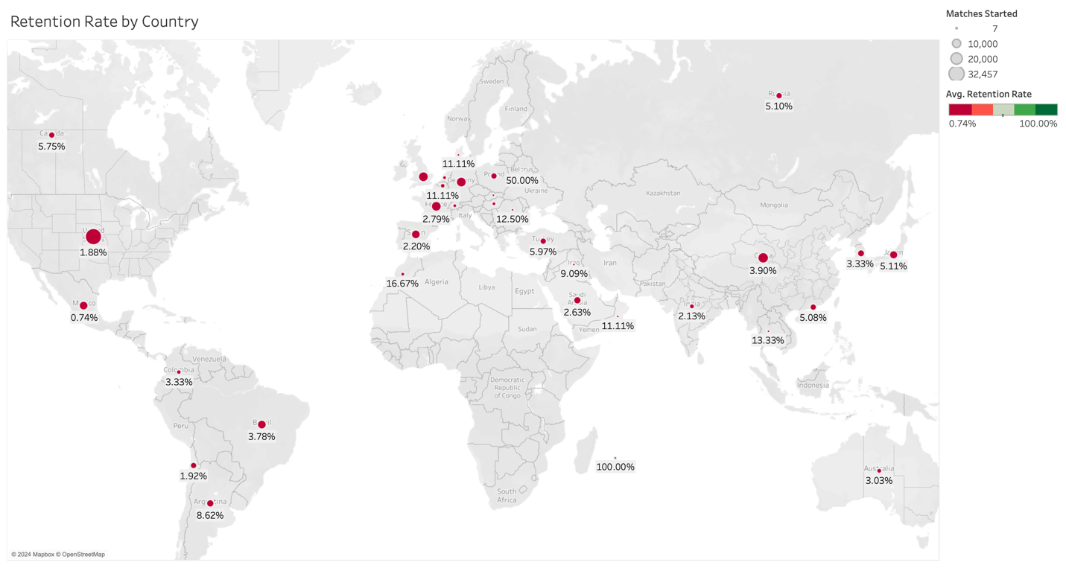

**Fig 6 (Winrate by Country)**

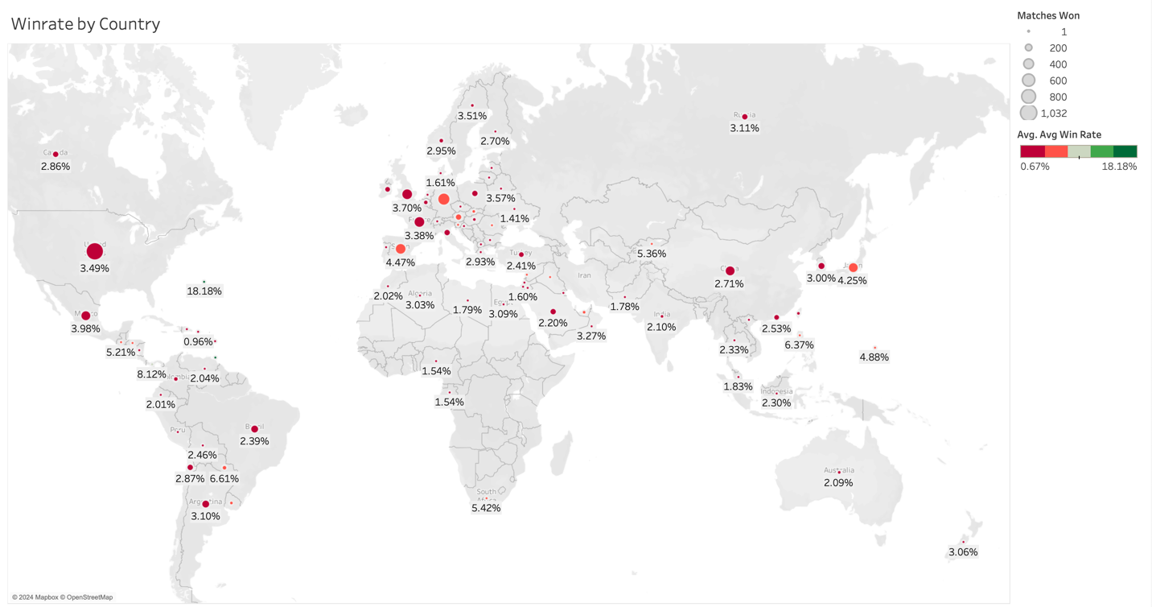

**Fig 7 (Trend Lines for Match Start vs Match Complete vs Match Won)**

